|  |
| --- |
| Distributed & Scalable Data  Engineering – Technical Report |

|  |
| --- |
| Electrical & Computer Engineering & Computer Science (ECECS) |

|  |  |
| --- | --- |
| Fall 2024 |  |



Contents

Project Name 2

Executive Summary 2

Technical Report 3

Highlights of Project 3

Submitted on: 3

Abstract 4

Methodology 5

Results Section 5

Discussion 6

Conclusion 6

|  |
| --- |
| Project Name |

|  |  |  |
| --- | --- | --- |
| Executive Summary The “**Comprehensive Analysis of Real Estate Market**” project examines the factors influencing residential property prices, focusing on the impact of COVID-19. Using the CAMA dataset and CRISP-DM methodology, the team built linear regression models to predict prices, achieving an R-squared of 0.6539. Key drivers like bedrooms, bathrooms, and gross building area were found to significantly impact prices. COVID-19 led to higher demand for larger homes, rising prices, and increased sales volume. The project utilized AWS S3, Athena, Glue, and SageMaker for data processing and modeling, providing actionable insights for real estate stakeholders. | | |
| person at a table writing in a notebook with people around | | |
| **Team Members:**  **Sai Siddu Vardhan Reddy Annadi**  **Vinay Kumar Reddy Punuru**  **Shiva Priya Pillalamarri** | **Questions?**  Contact : [sanna10@unh.newhaven.edu](mailto:sanna10@unh.newhaven.edu)  [vpunu2@unh.newhaven.edu](mailto:vpunu2@unh.newhaven.edu)  [spill6@unh.newhaven.edu](mailto:spill6@unh.newhaven.edu) |  |

|  |
| --- |
| Technical Report |

|  |  |
| --- | --- |
| **Comprehensive Analysis of Real Estate Market** |  |
| Highlights of Project The “Comprehensive Analysis of Real Estate Market” project explores key factors affecting residential property prices, especially during and after COVID-19. Using the CAMA dataset and CRISP-DM methodology, the team built linear regression models with predictors like bedrooms, bathrooms, property condition, and gross building area, achieving an R-squared of 0.6539. Analysis revealed that COVID-19 significantly influenced housing prices, driving demand for larger homes and suburban living. Data processing and modeling were conducted using AWS S3, Athena, Glue, and SageMaker, offering valuable insights for real estate stakeholders to adapt to evolving market trends.  Submitted on : 12-08-2024 bmitted on: |

## Abstract

The **“Comprehensive Analysis of Real Estate Market”** project aims to identify key factors influencing residential property prices, with a special focus on the impact of **COVID-19**. Using the **CAMA dataset from Open Data DC** and following the **CRISP-DM methodology**, the project analyzes property characteristics, neighborhood factors, and lifestyle changes to understand price fluctuations. The team developed **linear regression models** with predictors like bedrooms, bathrooms, property condition, and gross building area, achieving an **R-squared of 0.6539**, indicating strong predictive performance. The analysis highlights the influence of COVID-19, which shifted buyer preferences toward larger homes, suburban living, and proximity to recreational spaces. Data was processed and modeled using **AWS tools** like **S3, Athena, Glue, and SageMaker**, ensuring efficient data handling and deployment. The findings offer valuable insights for real estate stakeholders, developers, and policymakers to adapt to changing market dynamics and make data-driven decisions.

Pitch: <https://github.com/siddureddy-DS/Team08-DSCI-6007-01>

Executive Summary

The “**Comprehensive Analysis of Real Estate Market**” project examines the factors influencing residential property prices, focusing on the impact of COVID-19. Using the CAMA dataset and CRISP-DM methodology, the team built linear regression models to predict prices, achieving an R-squared of 0.6539. Key drivers like bedrooms, bathrooms, and gross building area were found to significantly impact prices. COVID-19 led to higher demand for larger homes, rising prices, and increased sales volume. The project utilized AWS S3, Athena, Glue, and SageMaker for data processing and modeling, providing actionable insights for real estate stakeholders.

Introductory Section

The **“Comprehensive Analysis of Real Estate Market”** project addresses the evolving nature of residential property prices, particularly in the context of the **COVID-19 pandemic**. Traditionally, factors like property size, location, and neighborhood characteristics have driven real estate prices. However, the pandemic introduced new dynamics, such as increased demand for larger living spaces, remote work flexibility, and a growing preference for suburban living. These changes have reshaped buyer behavior, creating both challenges and opportunities for real estate developers, investors, and policymakers.

This project aims to provide a **data-driven approach** to understanding these shifts by analyzing the **CAMA dataset from Open Data DC**. The study leverages the **CRISP-DM methodology** to explore key predictors of property prices, including the number of bedrooms, bathrooms, property condition, and gross building area. To ensure robust analysis and model development, the project employs a suite of **AWS cloud tools**, including **S3 for data storage, Athena for querying, Glue for ETL, and SageMaker for machine learning**.

The analysis is segmented into three phases—**pre-COVID, during COVID, and post-COVID**—to capture the unique effects of the pandemic on property demand and prices. By building and testing **linear regression models**, the project aims to provide insights into the key factors that influence residential property prices. The results will enable real estate stakeholders to make informed decisions, adapt to new market demands, and seize growth opportunities in the evolving housing market.

## 

## Methodology

CRISP-DM methodology :

Title of the Project : Comprehensive Analysis of Real Estate Market

Business Understanding:

The primary goal of this project is to provide actionable insights for real estate stakeholders, developers, and policymakers to better understand the changing landscape of residential property prices. By using the CAMA dataset from Open Data DC, the project seeks to address key business questions, including:

1. What factors most significantly influence property prices?
2. How have property sales and price trends changed before, during, and after COVID-19?
3. Which property features, like bedrooms, bathrooms, property condition, and gross building area, impact the selling price the most?
4. How can developers and investors adapt their strategies to meet shifting buyer demands?

Data Understanding:

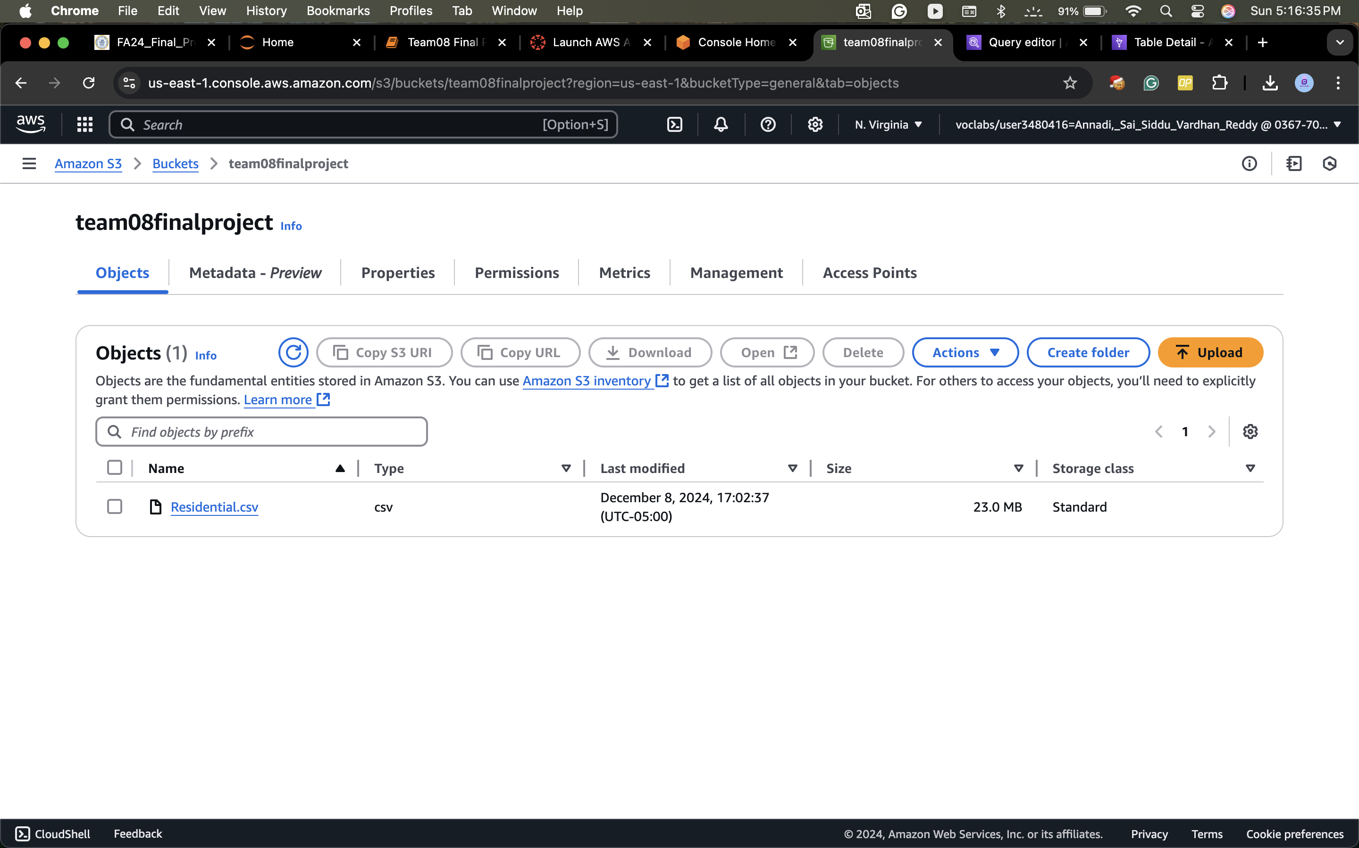

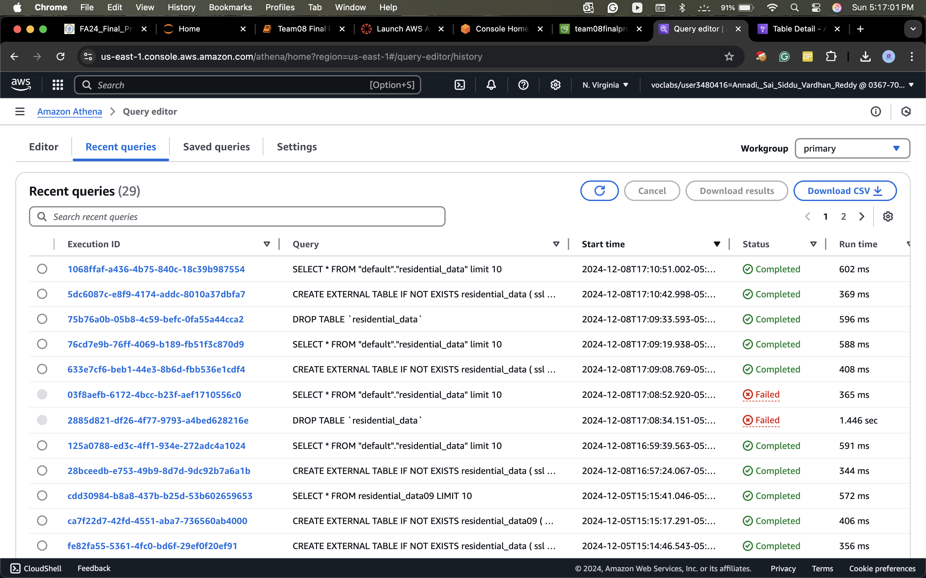

Data Preparation: Loading Data to Schema - AWS Glue: Loading Data to Schema

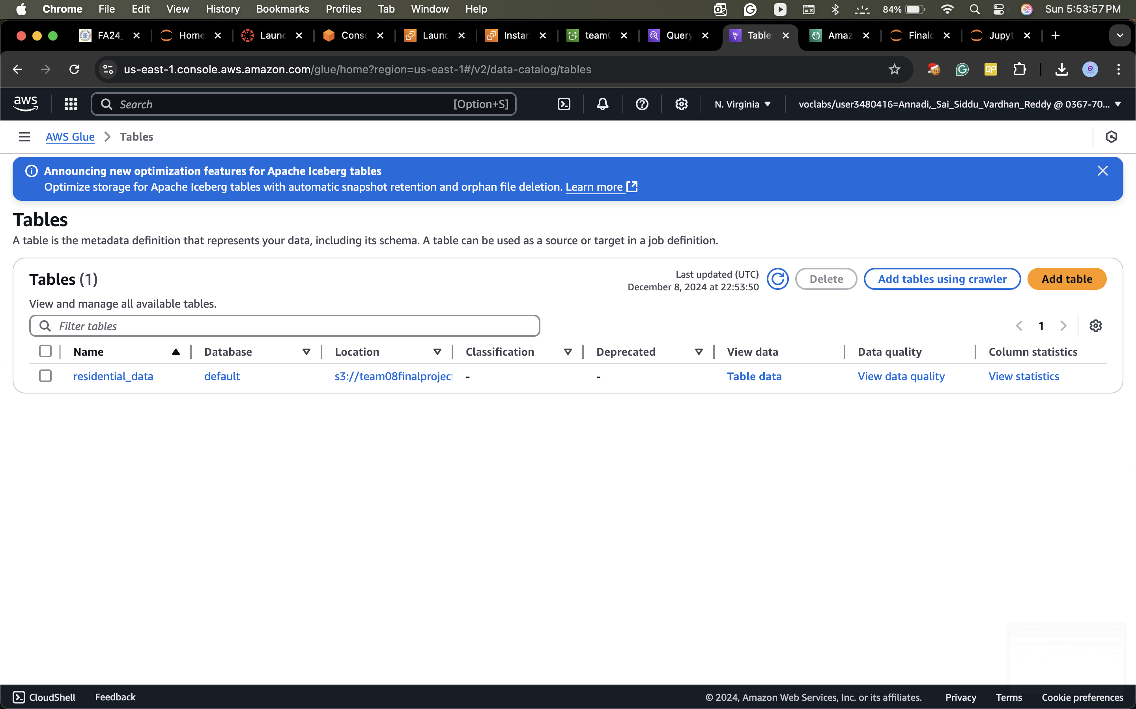

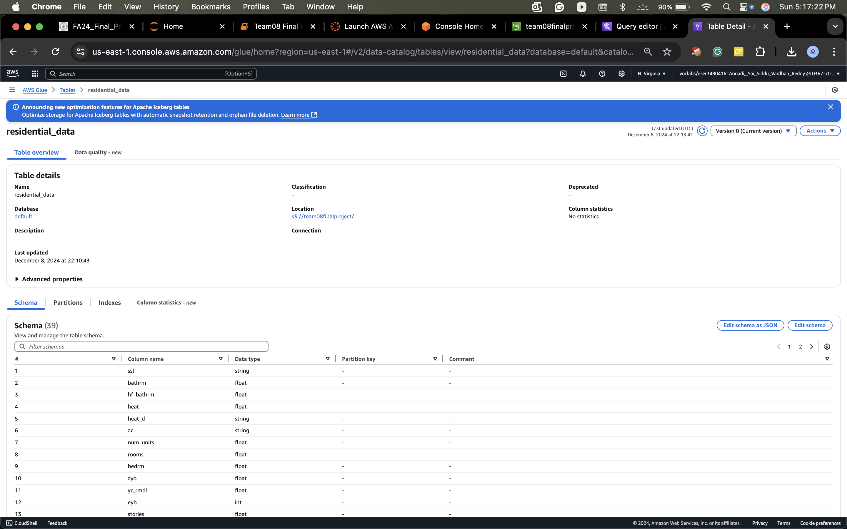

Transforming the Cleaning Data

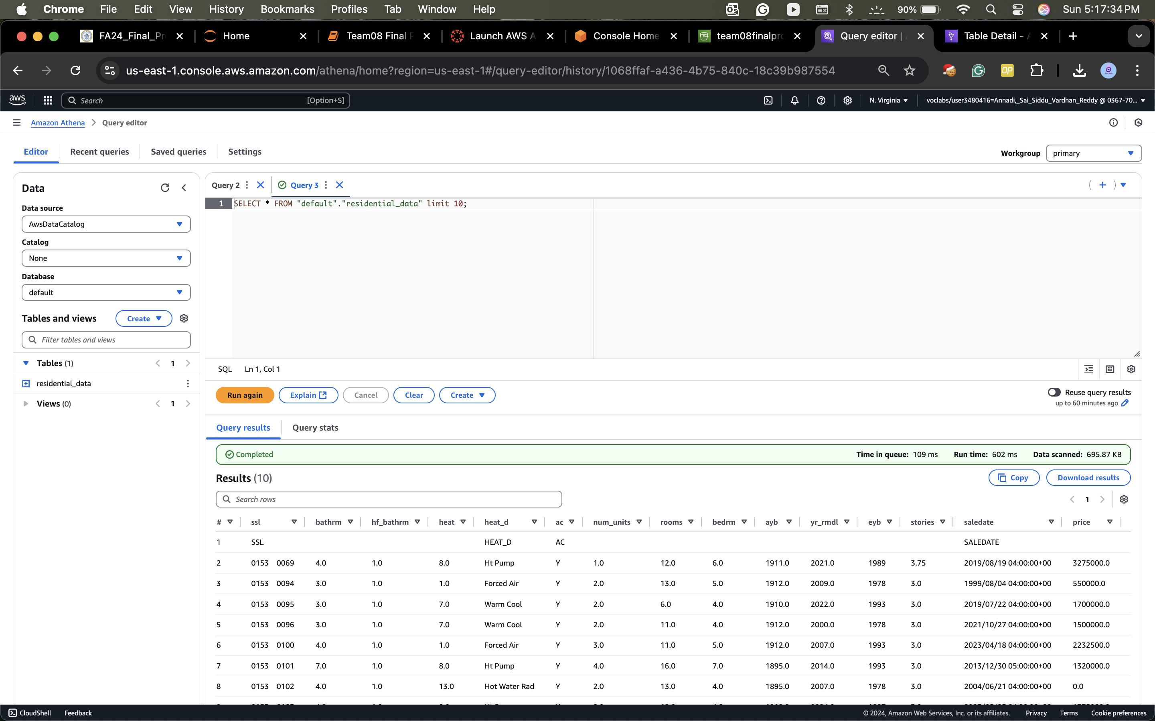

Modeling: AWS Sage Maker and Sagamaker Notebook Instances

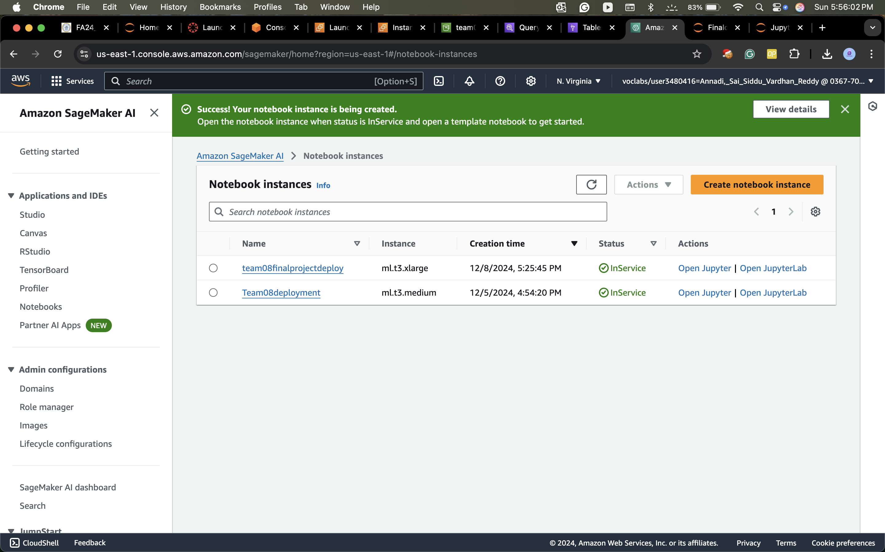

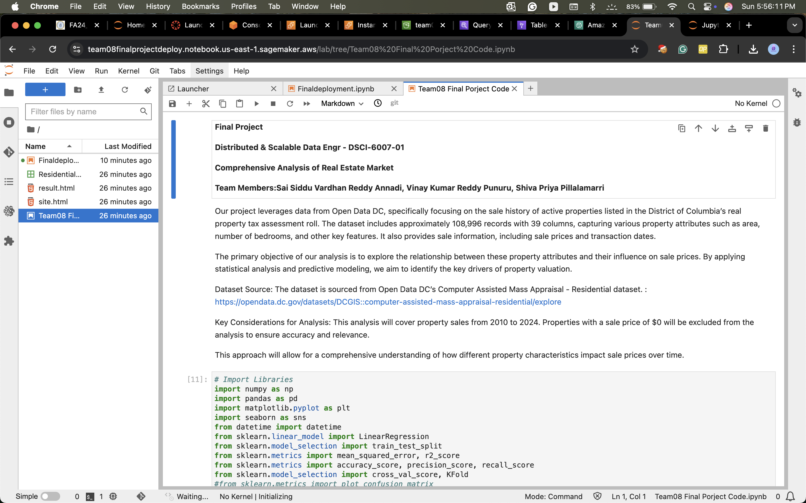

Evaluation - Data Analysis:

Property Sales by Price and Remodeled Status

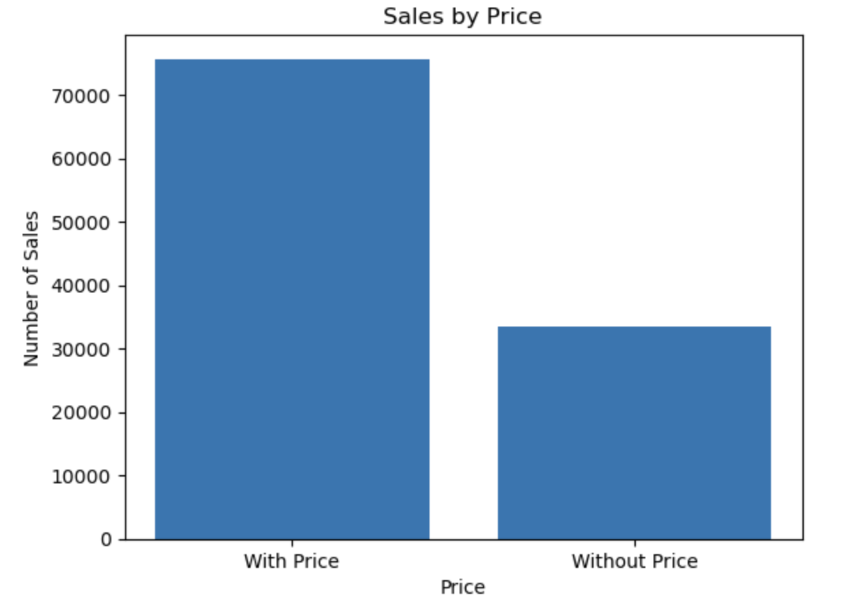 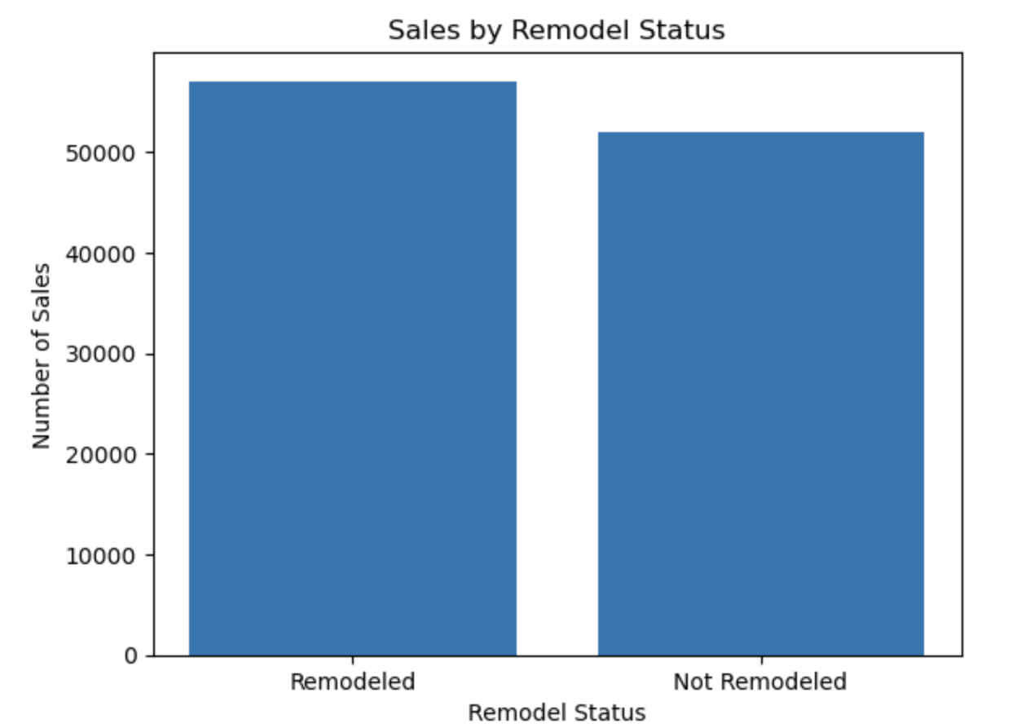

Annual and Monthly property sales trends

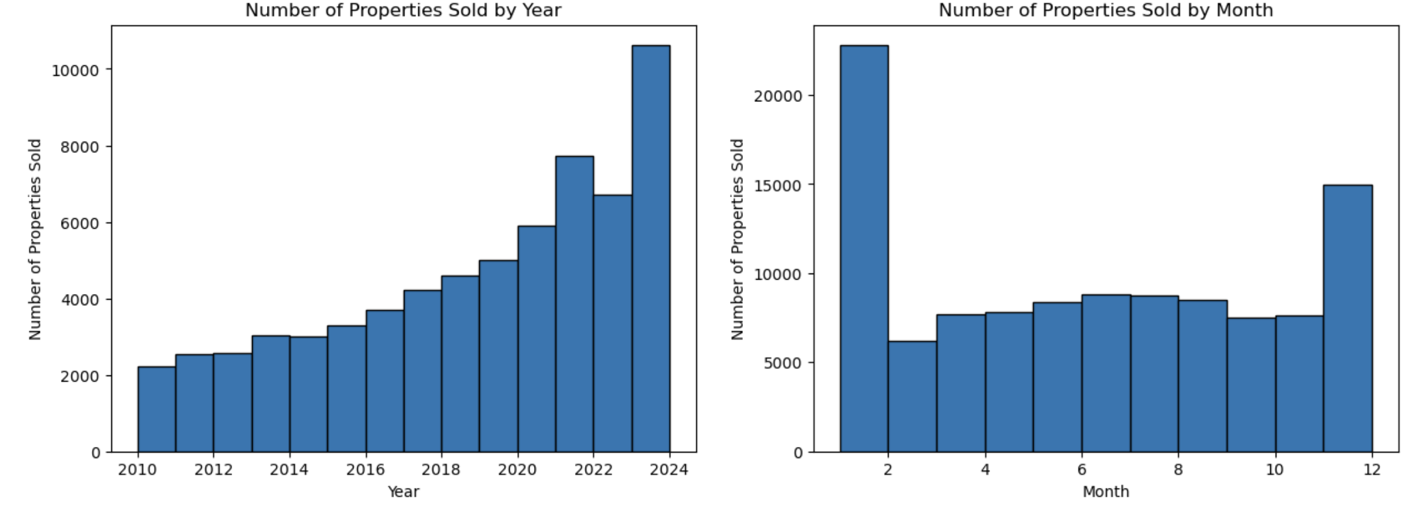

Distribution of Sale Prices for Trimmed Sales Data with KDE Plot

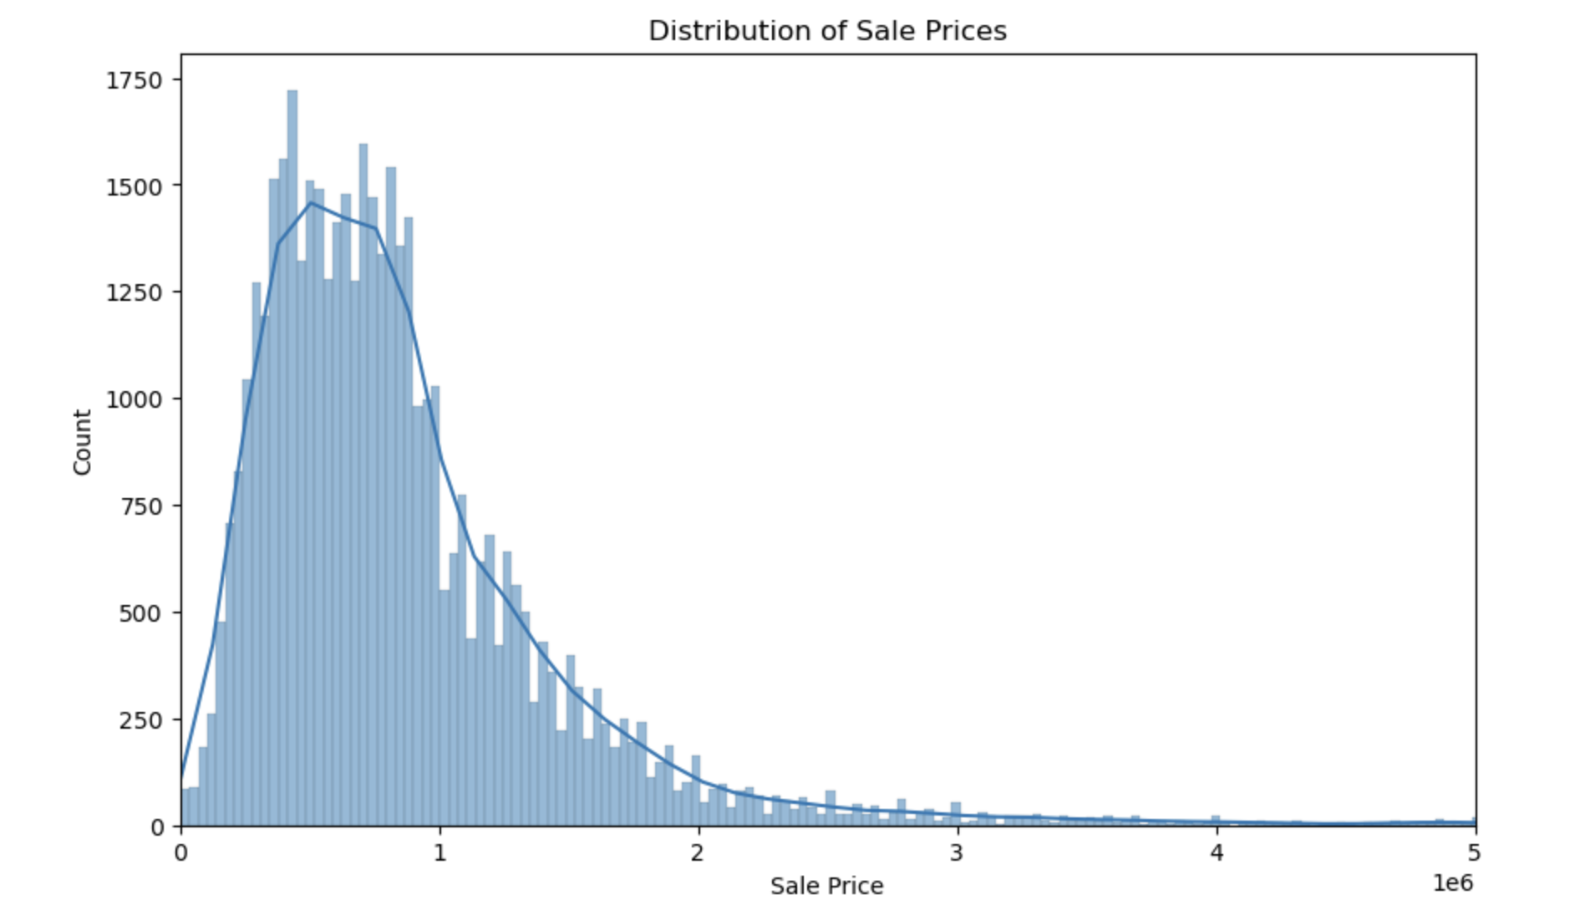

Annual Property Sales Comparison with and without Price

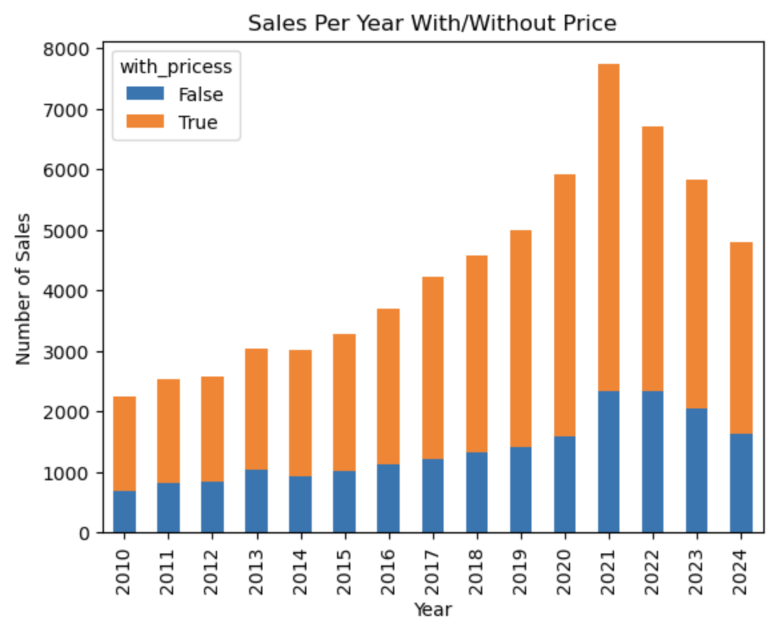

Results:

Model: Build LR model: Adding gross building area another predictor

* X : bathrm, bedrm, grade, heat, cndtn, gba
* Y: price

=== Linear Regression Summary ===

* Independent variables: ['bathrm', 'bedrm', 'grade', 'heat', 'cndtn', 'gba’]
* Dependent variable: price
* Training data size: 24499
* Test data size: 6125
* Mean squared error: 212482373114.2765
* R-squared: 0.6539350923078139
* Coefficients: [ 45474.64703669 -72781.65407855 221173.8025435 857.96809526 257221.10348558 434.47093989]

Data Engineering Pipeline:

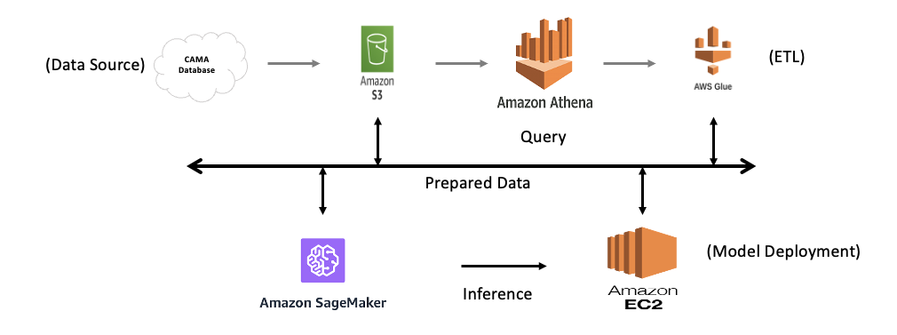

1. Data Ingestion:

• Data is sourced from databases or data lakes.

• This data is then stored in Amazon S3

2. Data Storage:

• Amazon Athena is used to query and analyze the data directly stored in Amazon S3. Athena enables running SQL queries on this data without managing a data warehouse.

3. Data Processing:

• The processed data is prepared for machine learning using Amazon SageMaker, which is used for building, training, and deploying machine learning models.

4. Model Deployment:

• The models are deployed using Amazon EC2 instances to perform inferences on the prepared data.

• Additionally, AWS Glue is used to handle ETL (Extract, Transform, and Load) processes, transforming data between various sources and destinations.

5. Data Visualization:

• Results from the analysis, such as property sales trends and prices, are visualized for interpretation and reporting.

Deployment

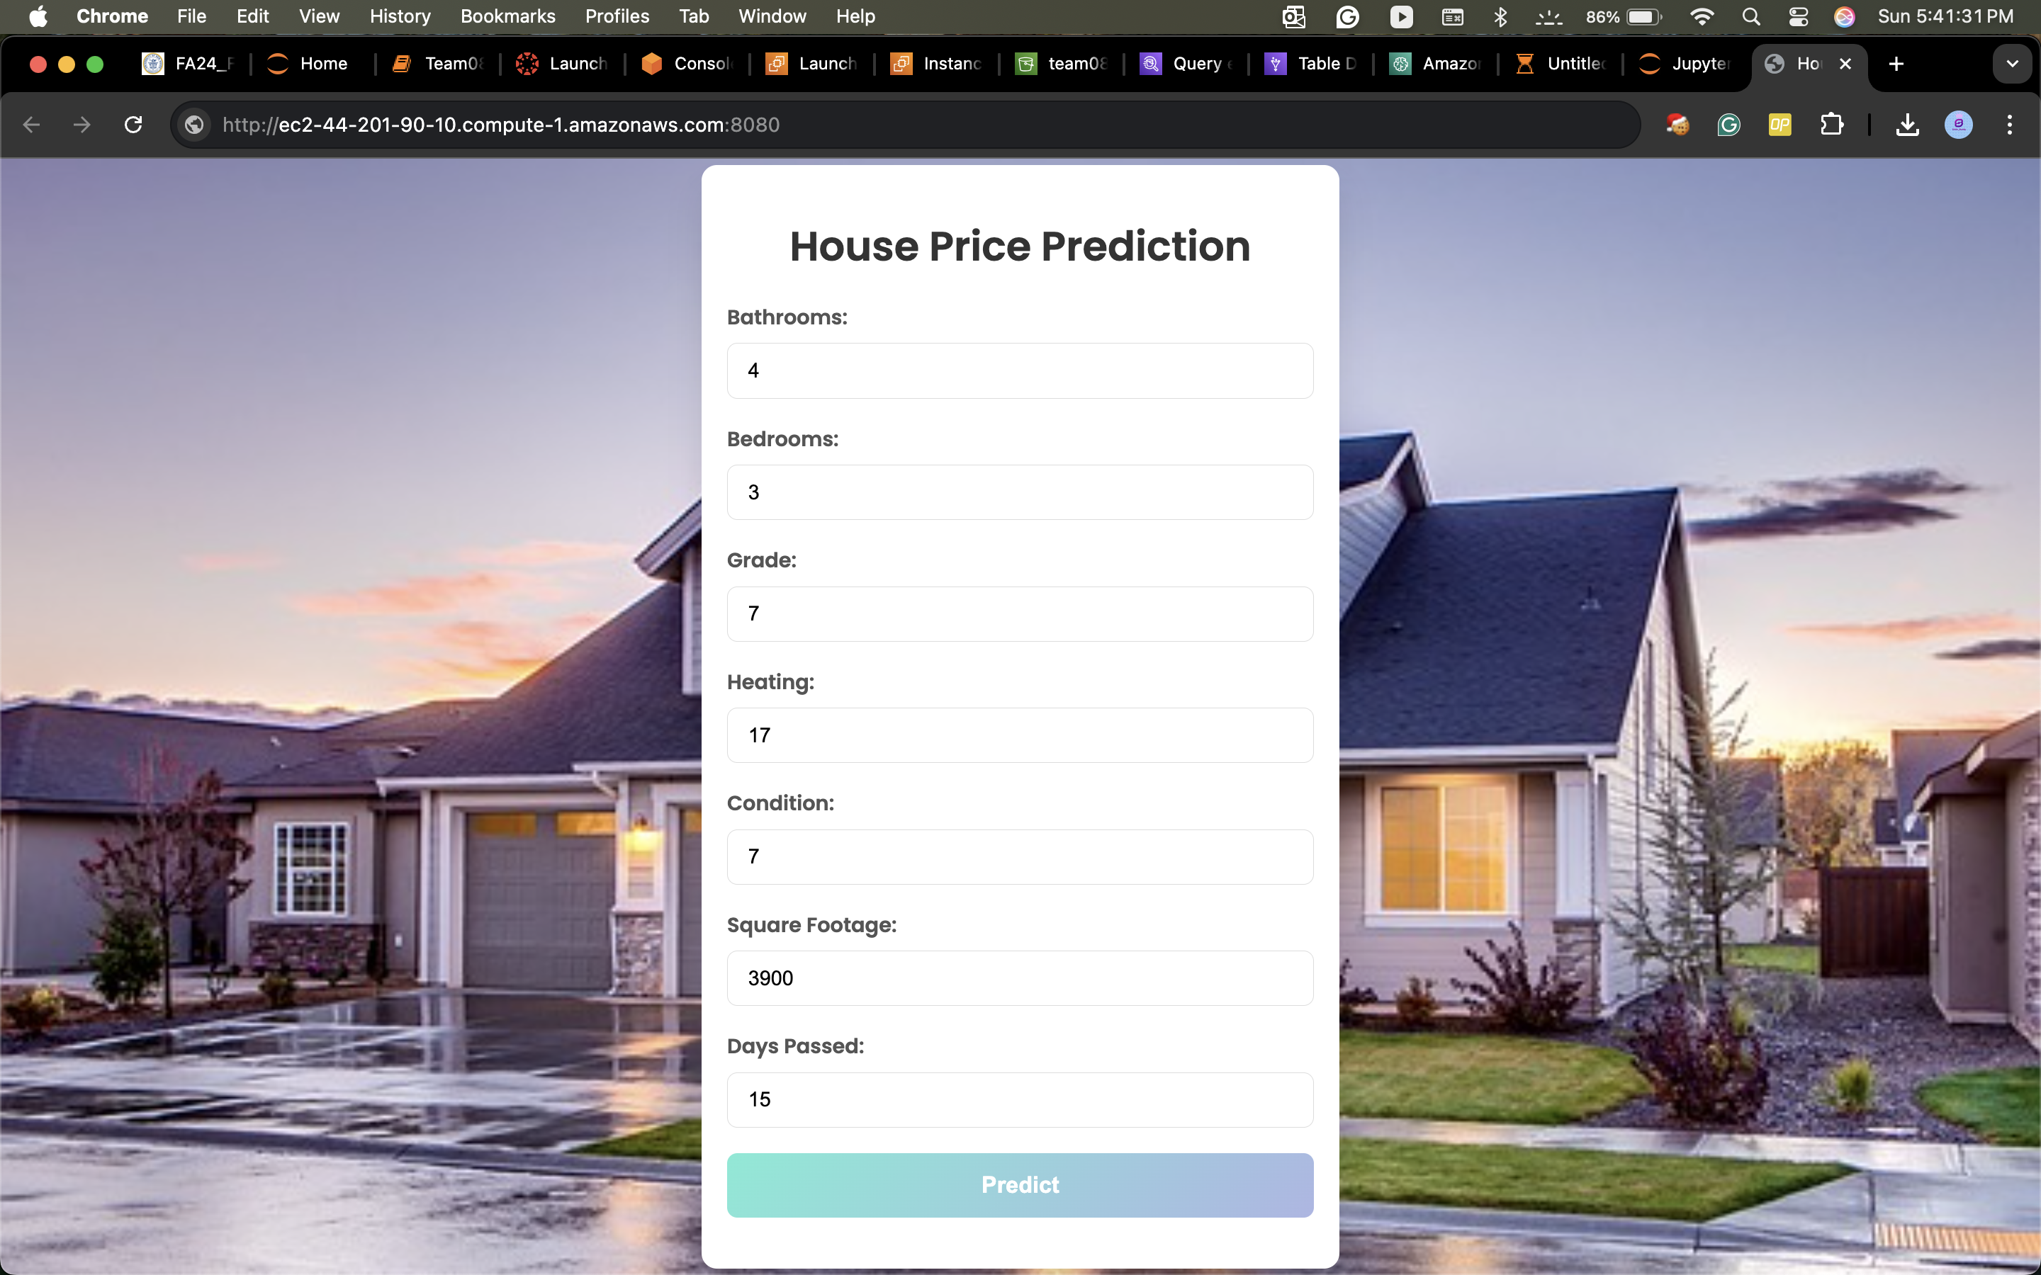

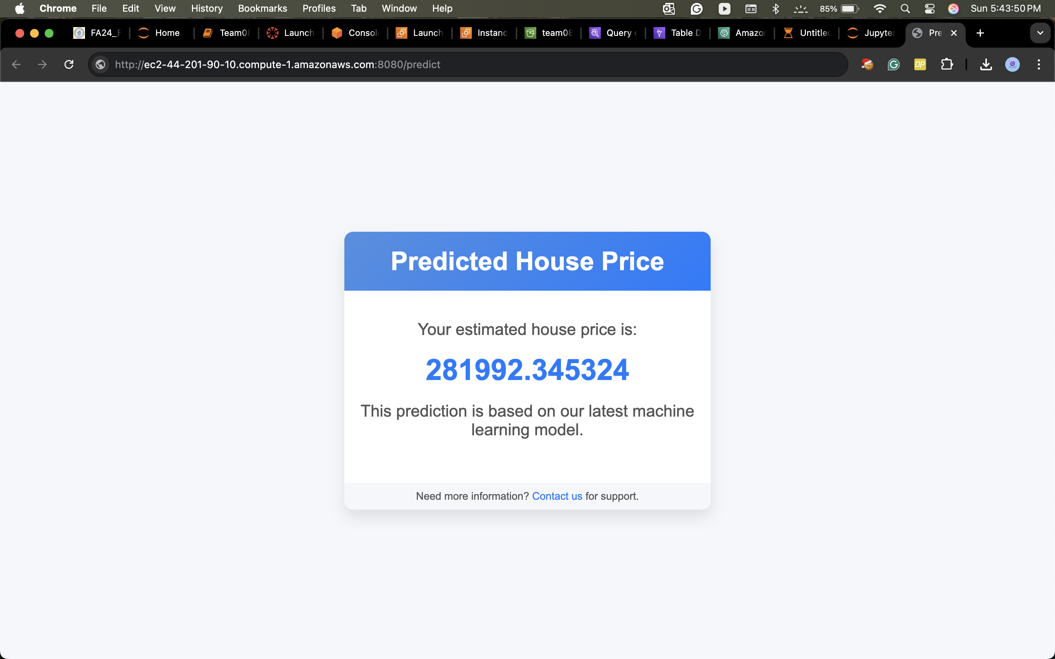

Discussion

COVID-19 Impact

Time Period Segmentation:

* Pre-COVID (ExAnte) Period: January 1, 2019 – February 29, 2020
* During COVID Period: March 1, 2020 – July 31, 2021
* Post-COVID (ExPost) Period: August 1, 2021 – December 31, 2022

Price Fluctuations:

Significant shifts in residential property prices were observed before, during, and after the COVID-19 pandemic. Noticeable differences in price trends highlight the impact of the pandemic on housing demand and market conditions.

Inflation Adjustment:

To ensure a more accurate comparison of house prices across the three periods, property prices were deflated using the inflation rate, minimizing the influence of general price fluctuations.

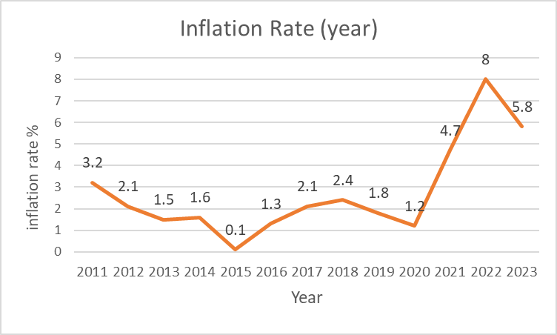

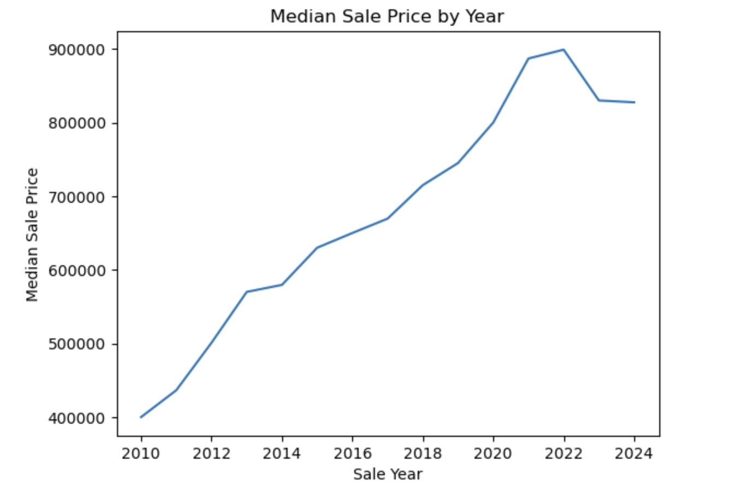

Price Comparison by Property Features:

Analyzing house price levels by the number of bedrooms, number of bathrooms, and overall property condition reveals distinct differences in pricing trends across the three periods. Properties with certain features, such as larger living spaces and better conditions, experienced greater price fluctuations, reflecting shifts in buyer preferences driven by the COVID-19 pandemic.

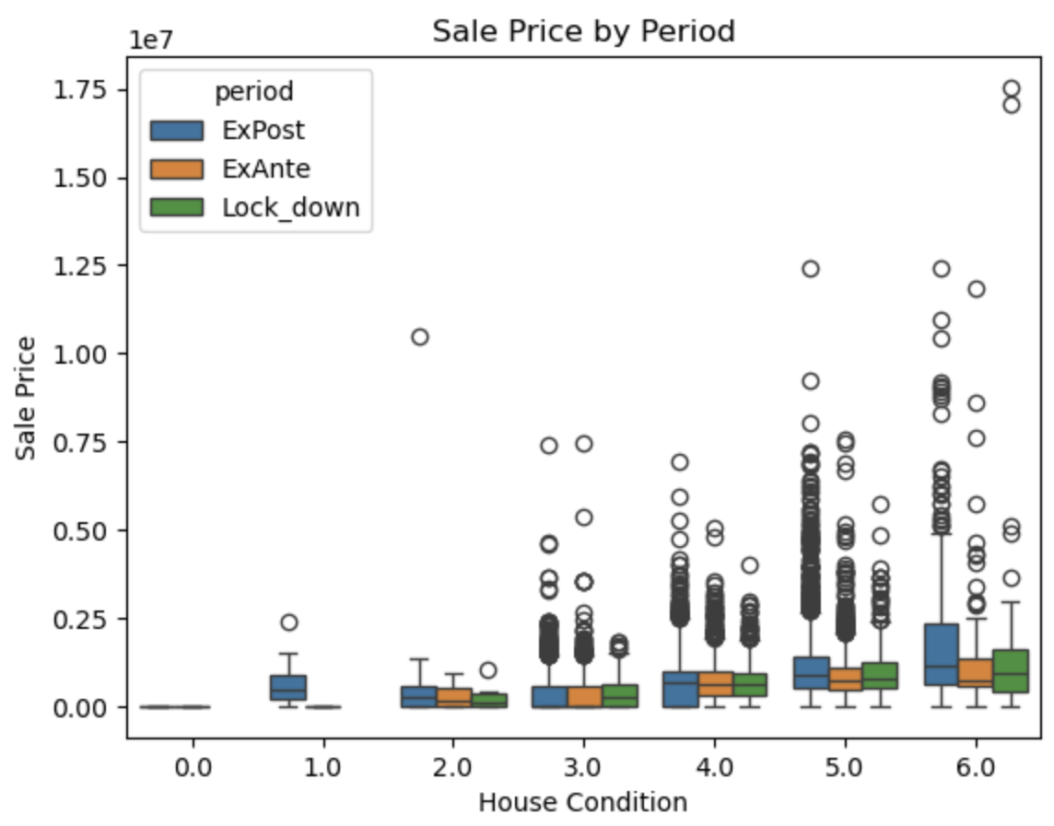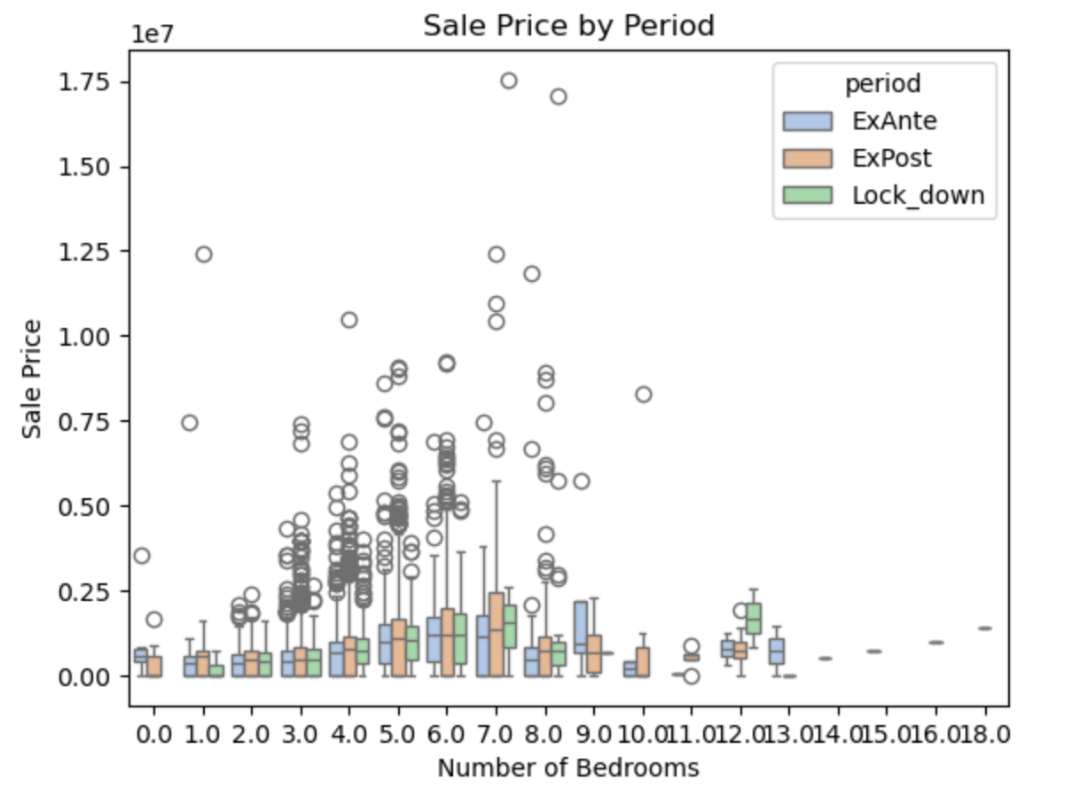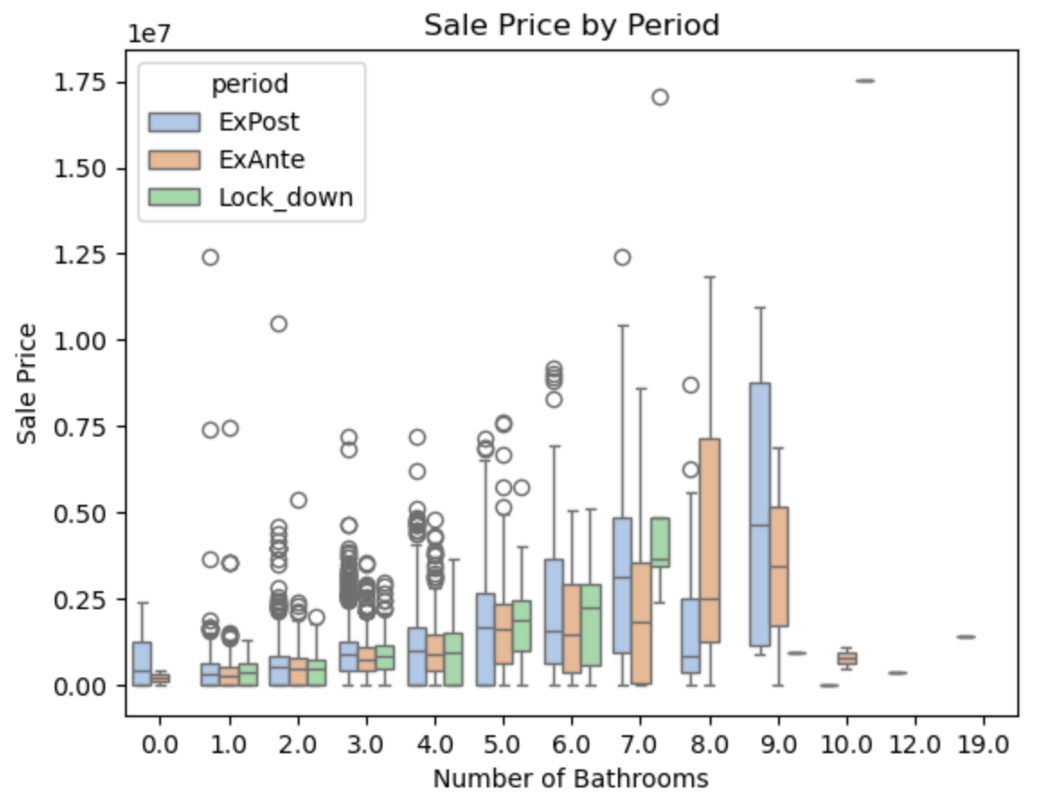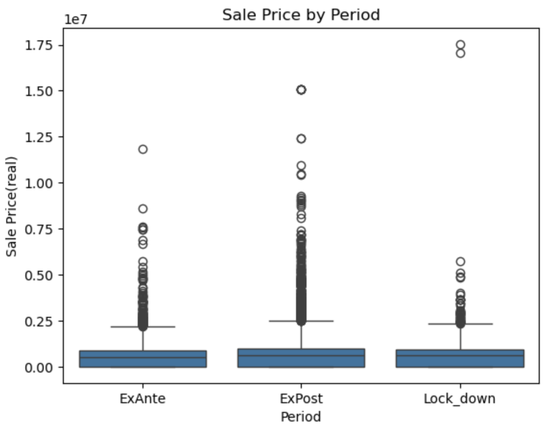

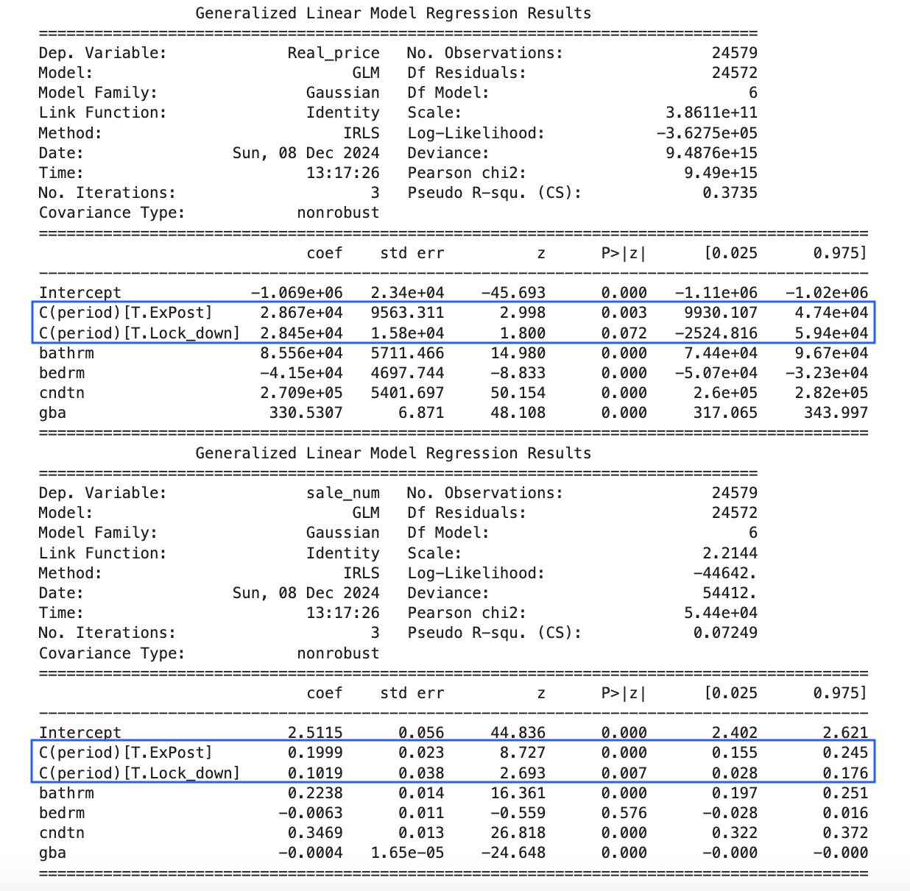

The COVID-19 period had a positive impact on housing prices and sales volume.

• Increase in Housing Prices: Compared to the Pre-COVID (ExAnte) period, housing prices rose significantly during and after the COVID period, reflecting increased demand for residential properties.

• Increase in Sales Volume: Similarly, sales volume saw a noticeable rise during and after COVID compared to the ExAnte period, indicating higher buyer activity and market engagement.

Conclusion

The “Comprehensive Analysis of Real Estate Market” project provides a data-driven understanding of the factors influencing residential property prices, with a focus on the impact of COVID-19. By leveraging the CAMA dataset and utilizing the CRISP-DM methodology, the project explored how property features, market trends, and pandemic-induced lifestyle changes shaped the real estate market. Key predictors such as bedrooms, bathrooms, property condition, and gross building area were identified as significant factors impacting property prices. The development of linear regression models with an R-squared of 0.6539 demonstrated the effectiveness of incorporating additional predictors for more accurate price forecasting.

The analysis revealed a significant rise in housing prices and sales volume during and after COVID, driven by shifts in buyer preferences toward larger homes, suburban living, and better living conditions. The segmentation of the data into Pre-COVID, During-COVID, and Post-COVID periods highlighted clear differences in pricing and demand trends. The use of AWS tools (S3, Athena, Glue, SageMaker) facilitated efficient data handling, analysis, and model deployment.

This project offers valuable insights for real estate developers, investors, and policymakers, enabling them to make informed, data-driven decisions. The findings emphasize the importance of adapting to evolving market demands, especially as buyer preferences continue to shift in the post-pandemic era. These insights can be used to optimize development strategies, identify emerging investment opportunities, and create more resilient market responses to future disruptions.

Contributions/References

1. Dabreo, S., Rodrigues, S., Rodrigues, V., & Shah, P. (2021). Real estate price prediction. *International Journal of Engineering Research & Technology*, 10(4). <https://www.ijert.org/research/real-estate-price-prediction-IJERTV10IS040322.pdf>
2. Akshay Babu, Dr. Anjana S Chandran , "Literature Review on Real Estate Value Prediction Using Machine Learning" , International Journal of Computer Science and Mobile Applications, Vol: 7 Issue: 3, 2019
3. Géron, A. (2019). *Hands-on machine learning with Scikit-Learn, Keras, and TensorFlow* (2nd ed.). O’Reilly Media. ISBN: 978-1-492-03264-9.
4. Duca, J. V., & Murphy, A. (2021). Why house prices surged as the COVID-19 pandemic took hold. *Federal Reserve Bank of Dallas*. <https://www.dallasfed.org/research/economics/2021/1228>
5. Schwartz, A. E., & Wachter, S. (2022). COVID-19’s impacts on housing markets: Introduction. *Journal of Housing Economics*.